THEFINWISE AI
Intelligent Loan Eligibility, Credit Analysis & Financial Advisory Platform
Project Report
Submitted by: REVANTH SRIRAM INTURI
Department of Computer Science and Engineering
Roll No:24481A05C7
Academic Year: 2026-27
College:Seshadri Rao Gudlavalleru Engineeringcollege

ACKNOWLEDGEMENT
We sincerely express our gratitude to our internship mentor for providing continuous guidance, encouragement, and valuable suggestions throughout this project.
We also thank our Department of Computer Science and Engineering, our faculty members, and our institution for providing the necessary facilities and support.
Finally, we thank our teammates for their cooperation and dedication in successfully completing this project.
ABSTRACT
TheFinWise AI is an AI-powered financial advisory platform that simplifies loan eligibility assessment and credit analysis. The application provides four major services: Loan Eligibility Checker, Credit Score Analyzer, EMI Calculator, and AI Financial Advisor.
The system analyzes user information such as monthly income, age, credit score, loan amount, and existing EMIs to determine loan eligibility and classify financial risk. It also generates personalized financial recommendations using AI and helps users improve their creditworthiness through practical suggestions.
The application is built using HTML, CSS, JavaScript, Python (Flask), Google Sheets, REST APIs, and AI integration. It offers a responsive interface with secure cloud-based data storage and real-time financial calculations.
This project demonstrates how Generative AI can be applied in financial technology to support intelligent decision-making and improve user financial planning. CONTENTS:
- Introduction
- Problem Statement
- Objectives
- Existing System
- Proposed System
- System Requirements
- Software Requirements
- Hardware Requirements
- System Architecture
- Modules
- Algorithms
- Database Design
- Implementation
- Testing
- Results
- code
- Advantages
- Limitations
- Future Scope
- SECURITY FEATURES
- PERFORMANCE ANALYSIS
- Conclusion

INTRODUCTION
Financial institutions receive thousands of loan applications every day. Manual verification of applicant information is time-consuming and may lead to inconsistent decisions. Many individuals also lack knowledge about loan eligibility, credit scores, and repayment planning.
TheFinWise AI addresses these challenges by providing an intelligent web application that automates financial analysis and assists users in making informed decisions. The platform combines Artificial Intelligence with financial calculations to evaluate loan eligibility, estimate EMIs, analyze credit scores, classify financial risks, and generate personalized financial advice.
The system is designed for salaried employees, self-employed individuals, students, and anyone planning to apply for a loan. It enables users to understand their financial position before approaching a bank or lending institution.

PROBLEM STATEMENT
Many people apply for loans without understanding whether they meet eligibility criteria. Traditional loan evaluation involves lengthy manual verification, which consumes significant time and resources. Users often do not know how their credit score affects approval, how much EMI they can afford, or how to improve their financial profile.
The project aims to develop an AI-powered platform that automates loan eligibility assessment, provides accurate EMI calculations, evaluates creditworthiness, and delivers personalized financial recommendations in a user-friendly environment
OBJECTIVES
The primary objectives of the project are:
- Develop an intelligent loan eligibility checker.
- Analyze customer credit scores.
- Calculate loan EMI accurately.
- Generate personalized financial advice using AI.
- Classify financial risk levels.
- Store user information securely.
- Provide responsive web access across devices.
- Improve financial awareness among users.
- Reduce manual loan evaluation effort.
- Support informed financial decision-making.
EXISTING SYSTEM
The existing loan evaluation process in many banks and financial institutions is primarily manual. Customers must visit the bank, submit multiple documents, and wait several days for verification and approval. Loan officers manually analyze income, credit history, liabilities, and repayment capacity before making a decision.
Disadvantages of Existing System
- Time-consuming loan approval process.
- Manual verification increases workload.
- Human errors may occur during evaluation.
- No personalized financial guidance.
- Limited access to loan eligibility information.
- Users cannot easily estimate EMI before applying.
- Credit improvement suggestions are generally unavailable.
PROPOSED SYSTEM
The proposed system, TheFinWise AI, is a web-based intelligent financial advisory platform that automates loan eligibility analysis using predefined financial rules and AI-powered recommendations.
The application allows users to:
- Check loan eligibility instantly.
- Analyze their credit score.
- Calculate EMI accurately.
- Receive AI-generated financial recommendations.
- Understand financial risk levels.
- Improve credit scores through personalized guidance.
The platform provides faster, more accurate, and user-friendly financial decision support.
Advantages of Proposed System
- Fast loan eligibility assessment.
- AI-based financial recommendations.
- Accurate EMI calculations.
- Responsive user interface.
- Easy-to-use dashboard.
- Secure cloud data storage.
- Credit score improvement suggestions.
- Reduced manual effort.
- Better financial planning.
SOFTWARE REQUIREMENTS
Software | Version
Operating System | Windows 10/11
Visual Studio Code | Latest
HTML5 | Latest
CSS3 | Latest
JavaScript | ES6
Python | 3.11+
Flask | Latest
Git | Latest
Google Chrome | Latest
Google Sheets | Cloud Database
HARDWAREREQUIREMENTS

Hardware | Requirement
Processor | Intel Core i5 / AMD Ryzen 5
RAM | Minimum 8 GB
Storage | 10 GB Free Space
Internet | Broadband Connection
Display | 1366 × 768 or above

SYSTEM ARCHITECTURE
USER

│

▼

HTML + CSS + JavaScript

│

▼

Flask Backend Server

│

┌───────────┴───────────┐

▼ ▼

Claude AI API Google Sheets

│ │

└───────────┬───────────┘

▼

Financial Analysis

│

▼

Results Dashboard

Loan Eligibility
Credit Score
EMI
Risk Analysis
Financial Tips

MODULES
Module 1
User Authentication
Users enter their financial information through a secure web interface.

Module 2
Loan Eligibility Checker
Inputs:
- Salary
- Age
- Existing EMI
- Employment Type
- Credit Score
Output:
- Eligible
- Not Eligible
- Maximum Loan Amount
- Risk Level

Module 3
Credit Score Analyzer
Classifies the user's credit score into categories:
Credit Score | Status
300–579 | Poor
580–669 | Fair
670–739 | Good
740–799 | Very Good
800–900 | Excellent

Module 4
EMI Calculator
Formula
$$EMI=\frac{P×R×(1+R)^{N}}{(1+R)^{N}-1}$$
Where:
- P = Principal Loan Amount
- R = Monthly Interest Rate
- N = Loan Tenure in Months

Module 5
AI Financial Advisor
Provides:
- Financial Suggestions
- Budget Planning
- Credit Improvement Tips
- Risk Analysis
- Loan Recommendations

Module 6
Google Sheets Database
Stores:
- User Details
- Loan Applications
- Credit Analysis
- EMI Records
- AI Recommendations
SYSTEM FLOW
Start
↓
Enter User Details
↓
Validate Input
↓
Loan Eligibility Check
↓
Credit Score Analysis
↓
EMI Calculation

↓

AI Recommendation

↓

Display Result

↓

Store Data

↓

End
USE CASES
Scenario 1 – Salaried Applicant
- Salary: ₹45,000/month
- Credit Score: 730
- Existing EMI: ₹0
- Result:
  - Eligible
  - Maximum Loan: ₹9,00,000
  - Risk Level: Low
Scenario 2 – High-Risk Applicant
- Salary: ₹22,000
- Credit Score: 620
- Existing EMI: ₹18,000
- Result:
  - Not Eligible
  - Risk Level: High
  - Recommendation: Improve credit score before applying
Scenario 3 – EMI Planning
- Loan Amount: ₹5,00,000
- Interest Rate: 10.5%
- Tenure: 60 Months
- Output:
  - Monthly EMI
  - Total Interest
  - Total Repayment
Scenario 4 – Credit Improvement
- Credit Score: 580
- Classification: Poor
- AI Suggestions:
  - Pay EMIs on time
  - Reduce credit utilization
  - Avoid multiple loan applications
  - Maintain a healthy repayment history
- DATABASE DESIGN
- The project uses Google Sheets as a lightweight cloud database to store user financial details, loan eligibility results, EMI calculations, and AI-generated recommendations.
- Table: User Details
Field Name | Data Type | Description
User_ID | Integer | Unique User ID
Full_Name | Varchar | User Name
Age | Integer | User Age
Employment_Type | Varchar | Salaried/Self-Employed
Monthly_Income | Decimal | Monthly Salary
Existing_EMI | Decimal | Current EMI
Credit_Score | Integer | Credit Score
Loan_Amount | Decimal | Requested Loan
Loan_Tenure | Integer | Months
Interest_Rate | Decimal | Annual Interest
Eligibility | Varchar | Eligible/Not Eligible
Risk_Level | Varchar | Low/Medium/High
Recommendation | Text | AI Financial Advice
ALGORITHMS
Algorithm 1: Loan Eligibility
Step 1: Start
Step 2: Read salary, age, credit score, existing EMI, and loan amount.
Step 3: Validate user input.
Step 4: Calculate Debt-to-Income (DTI) ratio.
Step 5: If credit score ≥ 700 and DTI < 40%, then approve the loan.
Step 6: Otherwise, reject or suggest a lower loan amount.
Step 7: Display eligibility result.
Step 8: End.
Algorithm 2: Credit Score Classification
- Read the user's credit score.
- If score < 580 → Poor.
- If score 580–669 → Fair.
- If score 670–739 → Good.
- If score 740–799 → Very Good.
- If score ≥ 800 → Excellent.
- Display classification and suggestions.
Algorithm 3: EMI Calculation
- Read principal amount (P).
- Read annual interest rate (R).
- Read tenure in months (N).
- Convert annual interest to monthly interest.
- Apply the EMI formula.
- Display monthly EMI, total interest, and total repayment

TESTING
Test Case 1
Test Item | Value
Monthly Salary | ₹45,000
Credit Score | 730
Existing EMI | ₹0
Expected Result | Loan Approved
Actual Result | Loan Approved
Status | Pass

Test Case 2
Test Item | Value
Monthly Salary | ₹22,000
Credit Score | 620
Existing EMI | ₹18,000
Expected Result | Loan Rejected
Actual Result | Loan Rejected
Status | Pass
Test Case 3
Test Item | Value
Loan Amount | ₹5,00,000
Interest Rate | 10.5%
Tenure | 60 Months
Expected Result | Correct EMI
Actual Result | Correct EMI
Status | Pass

RESULTS
The developed application successfully performs:
- Loan eligibility assessment.
- Credit score classification.
- EMI calculation.
- Financial risk analysis.
- AI-generated financial recommendations.
- Secure data storage using Google Sheets.
- Responsive operation across desktop and mobile devices.
The system provides accurate financial insights in real time, enabling users to make informed borrowing decisions.
CODE:
1.index.html:
<!DOCTYPE html>
<html lang="en">
<head>
<meta charset="UTF-8">
<meta name="viewport" content="width=device-width, initial-scale=1.0">
<title>TheFinWise AI</title>
<style>
*{
margin:0;
padding:0;
box-sizing:border-box;
font-family:Arial, Helvetica, sans-serif;
}

body{
background:#f4f7fb;
}
header{
background:#0f172a;
color:white;
padding:15px 40px;
display:flex;
justify-content:space-between;
align-items:center;
}
nav a{
color:white;
text-decoration:none;
margin-left:20px;
font-weight:bold;
}
.hero{
text-align:center;
padding:80px 20px;
background:linear-gradient(135deg,#2563eb,#06b6d4);
color:white;
}

.hero h1{
font-size:45px;
}
.hero p{
margin-top:15px;
font-size:18px;
}
.container{
width:90%;
margin:auto;
padding:40px 0;
}
.cards{
display:grid;
grid-template-columns:repeat(auto-fit,minmax(250px,1fr));
gap:20px;
}
.card{
background:white;
padding:25px;
border-radius:12px;
box-shadow:0 0 10px rgba(0,0,0,.1);
text-align:center;
}
.card h3{
color:#2563eb;
margin-bottom:10px;
}
button{
margin-top:15px;
padding:10px 20px;
background:#2563eb;
color:white;
border:none;
border-radius:5px;
cursor:pointer;
}
button:hover{
background:#1d4ed8;
}
footer{
background:#0f172a;
color:white;
text-align:center;
padding:20px;
margin-top:40px;
}
</style>
</head>
<body>
<header>
<h2>TheFinWise AI</h2>
<nav>
<a href="#">Home</a>
<a href="#">Loan</a>
<a href="#">Credit</a>
<a href="#">EMI</a>
<a href="#">Advisor</a>
</nav>
</header>
<section class="hero">
<h1>Intelligent Loan Eligibility & Financial Advisor</h1>
<p>
Analyze your loan eligibility, credit score and EMI instantly.
</p>
<button onclick="welcome()">
Get Started
</button>
</section>
<div class="container">
<h2 style="text-align:center;margin-bottom:30px;">
Our Services
</h2>
<div class="cards">
<div class="card">
<h3>Loan Eligibility</h3>
<p>
Check whether you qualify for a loan based on income and credit score.
</p>
<button onclick="loan()">Open</button>
</div>
<div class="card">
<h3>Credit Score</h3>
<p>
Analyze your credit score and receive improvement tips.
</p>
<button onclick="credit()">Open</button>
</div>
<div class="card">
\<h3>EMI Calculator</h3>
<p>
Calculate monthly EMI and total repayment instantly.
</p>
<button onclick="emi()">Open</button>
</div>
<div class="card">
<h3>AI Financial Advisor</h3>
<p>
Receive smart financial recommendations for better planning.
</p>
<button onclick="advisor()">Open</button>
</div>
</div>
</div>
<footer>
© 2026 TheFinWise AI | Internship Project
</footer>
<script>
function welcome(){
alert("Welcome to TheFinWise AI");
}
function loan(){
alert("Loan Eligibility Module");
}
function credit(){
alert("Credit Score Analyzer");
}
function emi(){
alert("EMI Calculator");
}
function advisor(){
alert("AI Financial Advisor");
}
</script>
</body>
</html>
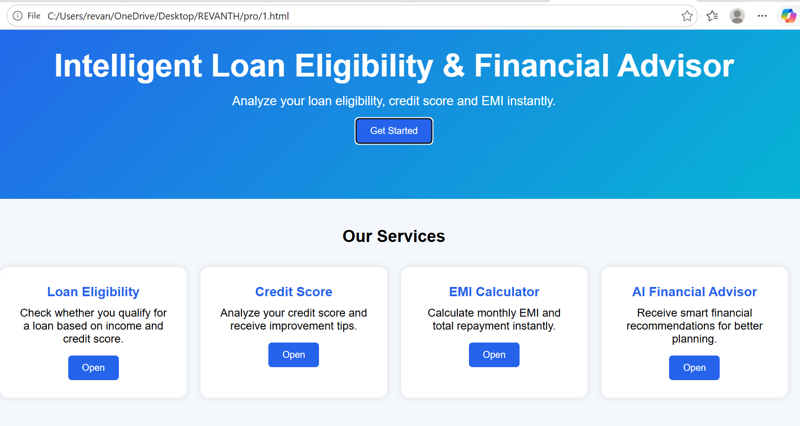
2.LOAN.html:
<!DOCTYPE html>
<html lang="en">
<head>
<meta charset="UTF-8">
<meta name="viewport" content="width=device-width, initial-scale=1.0">
<title>Loan Eligibility Checker</title>
<style
body{
font-family:Arial;
background:#f2f2f2;
}
.container{
width:500px;
margin:50px auto;
background:white;
padding:30px;
border-radius:10px;
box-shadow:0px 0px 10px gray;
}
h2{
text-align:center;
color:#1d4ed8;
}

input{
width:100%;
padding:10px;
margin:10px 0;
}

button{
width:100%;
padding:12px;
background:#2563eb;
color:white;
border:none;
cursor:pointer;
}
button:hover{
background:#1e40af;
}
#result{
margin-top:20px;
font-size:20px;
font-weight:bold;
}

</style>
</head>
<body>
<div class="container">
<h2>Loan Eligibility Checker</h2>
<input type="number" id="income" placeholder="Monthly Income">
<input type="number" id="credit" placeholder="Credit Score">
<input type="number" id="loan" placeholder="Loan Amount">
<button onclick="checkLoan()">
Check Eligibility
</button>
<p id="result"></p>
</div
<script>
function checkLoan(){
let income=parseInt(document.getElementById("income").value);
let credit=parseInt(document.getElementById("credit").value)
let loan=parseInt(document.getElementById("loan").value);
if(income>=30000 && credit>=700){
document.getElementById("result").innerHTML=
"✅ Congratulations! Loan Approved.";
}

else{
document.getElementById("result").innerHTML=
"❌ Sorry! Loan Rejected.";
}
}
</script>
</body>
</html>
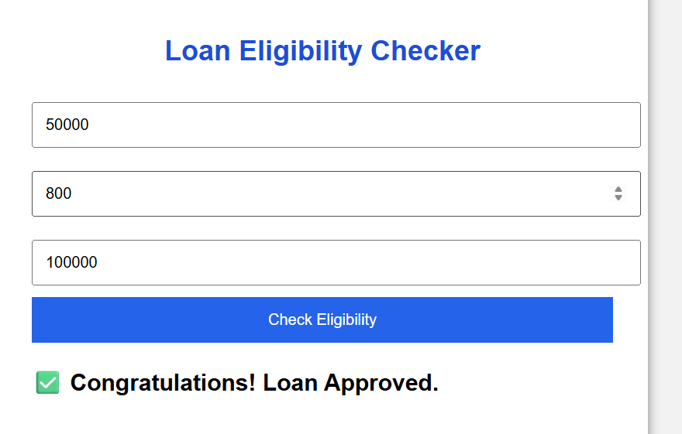
3.Credit.html
<!DOCTYPE html>
<html lang="en">
<head>
<meta charset="UTF-8">
<meta name="viewport" content="width=device-width, initial-scale=1.0">
<title>Credit Score Analyzer</title
<style>
*{
margin:0;
padding:0;
box-sizing:border-box;
font-family:Arial,sans-serif;
}
body{
background:#f4f7fc;
}
.container{
width:450px;
margin:50px auto;
background:white;
padding:30px;
border-radius:10px;
box-shadow:0px 0px 15px rgba(0,0,0,0.2);
}
h2{
text-align:center;
color:#2563eb;
margin-bottom:20px;
}
input{
width:100%;
padding:12px;
margin:10px 0;
font-size:16px;
}
button{
width:100%;
padding:12px;
background:#2563eb;
color:white;
border:none;
font-size:18px;
cursor:pointer;
border-radius:5px;
}
button:hover{
background:#1e40af;
}
.result{

margin-top:20px;
padding:15px;
background:#f2f2f2;
border-radius:8px;
font-size:18px;
}
</style
</head>
<body>
<div class="container">
<h2>Credit Score Analyzer</h2>
<input
type="number"
id="score"
placeholder="Enter Credit Score (300 - 900)"
min="300"
max="900">
<button onclick="analyzeCredit()">
Analyze Score
</button>
<div class="result" id="output">
Your Result Will Appear Here
</div>
</div>
<script>
function analyzeCredit(){
let score=parseInt(document.getElementById("score").value);
let message="";
let color="";
if(isNaN(score) || score<300 || score>900){
message="Please enter a valid credit score between 300 and 900.";
color="red";
}
else if(score>=800){
message="Excellent Credit Score\n\nApproval Chance : Very High\n\nRisk Level : Low";
color="green";
}
else if(score>=740){
message="Very Good Credit Score\n\nApproval Chance : High\n\nRisk Level : Low";
color="green";
}
else if(score>=670){
message="Good Credit Score\n\nApproval Chance : Medium\n\nRisk Level : Medium";
color="orange";
}
else if(score>=580){
message="Fair Credit Score\n\nApproval Chance : Low\n\nSuggestion:\nImprove your credit score before applying.";
color="darkorange";
}
else{
message="Poor Credit Score\n\nLoan Approval Unlikely\n\nSuggestion:\nPay bills on time, reduce debt, and improve your score.";
color="red";
}
document.getElementById("output").innerHTML=
message.replace(/\n/g,"<br>");
document.getElementById("output").style.color=color;
}
</script>
</body>
</html>
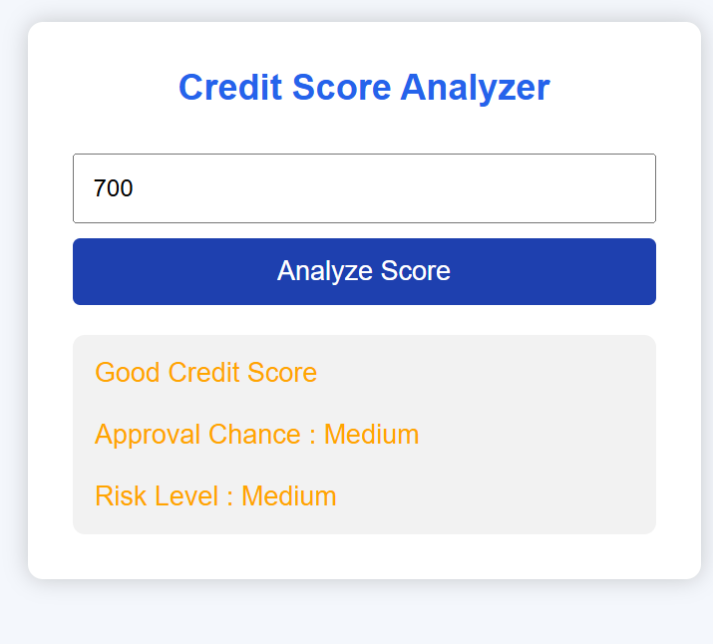
4.Emi.html:
<!DOCTYPE html>
<html lang="en">
<head>
<meta charset="UTF-8">
<meta name="viewport" content="width=device-width, initial-scale=1.0">
<title>EMI Calculator</title>
<style>
*{
margin:0;
padding:0;
box-sizing:border-box;
font-family:Arial,sans-serif;
}

body{
background:#eef2ff;
}

.container{
width:500px;
margin:40px auto;
background:white;
padding:30px;
border-radius:12px;
box-shadow:0 0 15px rgba(0,0,0,0.2);
}

h2{
text-align:center;
color:#1e3a8a;
margin-bottom:20px;
}

input{
width:100%;
padding:12px;
margin:10px 0;
font-size:16px;
}

button{
width:100%;
padding:12px;
background:#2563eb;
color:white;
font-size:18px;
border:none;
cursor:pointer;
border-radius:6px;
}

button:hover{
background:#1d4ed8;
}

.result{
margin-top:20px;
padding:15px;
background:#f8fafc;
border-radius:8px;
line-height:2;
font-size:18px;
}

</style>

</head>

<body>

<div class="container">

<h2>Loan EMI Calculator</h2>

<input type="number" id="loan" placeholder="Loan Amount">

<input type="number" id="rate" placeholder="Annual Interest Rate (%)">

<input type="number" id="years" placeholder="Loan Tenure (Years)">

<button onclick="calculateEMI()">

Calculate EMI

</button>

<div class="result" id="output">

Enter loan details and click Calculate.

</div>

</div>

<script>

function calculateEMI(){

let P=parseFloat(document.getElementById("loan").value);

let annualRate=parseFloat(document.getElementById("rate").value);

let years=parseFloat(document.getElementById("years").value);

if(isNaN(P)||isNaN(annualRate)||isNaN(years)||P<=0||annualRate<=0||years<=0){

document.getElementById("output").innerHTML=

"<span style='color:red;'>Please enter valid values.</span>";

return;

}

let R=annualRate/(12*100);

let N=years*12;

let EMI=(P*R*Math.pow((1+R),N))/(Math.pow((1+R),N)-1);

let totalPayment=EMI*N;

let interest=totalPayment-P;

document.getElementById("output").innerHTML=

"<b>Monthly EMI :</b> ₹ "+EMI.toFixed(2)+"<br><br>"+

"<b>Total Interest :</b> ₹ "+interest.toFixed(2)+"<br><br>"+

"<b>Total Payment :</b> ₹ "+totalPayment.toFixed(2);

}

</script>

</body>
</html>
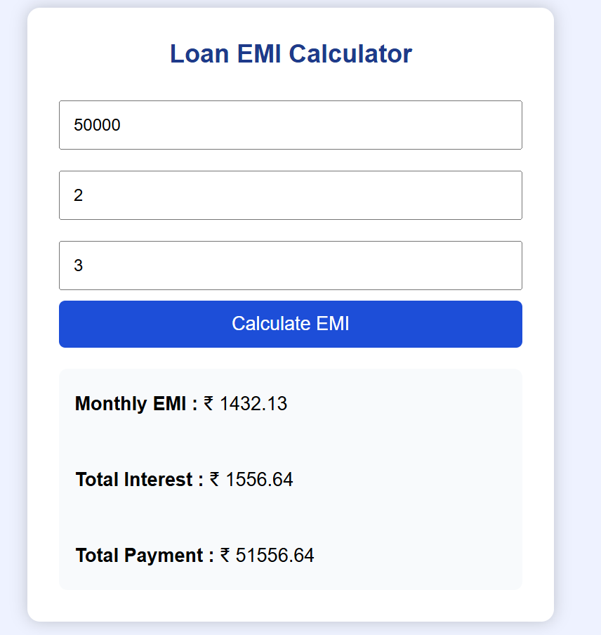
5.Advisor.html:
<!DOCTYPE html>
<html lang="en">
<head>
<meta charset="UTF-8">
<meta name="viewport" content="width=device-width, initial-scale=1.0">
<title>AI Financial Advisor</title>

<style>

*{
margin:0;
padding:0;
box-sizing:border-box;
font-family:Arial,sans-serif;
}

body{
background:#eef5ff;
}

.container{
width:600px;
margin:40px auto;
background:#fff;
padding:30px;
border-radius:10px;
box-shadow:0 0 15px rgba(0,0,0,0.2);
}

h2{
text-align:center;
color:#2563eb;
margin-bottom:20px;
}

label{
font-weight:bold;
}

input,select{
width:100%;
padding:10px;
margin:10px 0 20px;
border:1px solid #ccc;
border-radius:5px;
font-size:16px;
}

button{
width:100%;
padding:12px;
background:#2563eb;
color:white;
font-size:18px;
border:none;
border-radius:5px;
cursor:pointer;
}

button:hover{
background:#1d4ed8;
}

.result{
margin-top:20px;
padding:20px;
background:#f4f4f4;
border-radius:8px;
font-size:18px;
line-height:1.8;
}

</style>

</head>

<body>

<div class="container">

<h2>AI Financial Advisor</h2>

<label>Monthly Income (₹)</label>
<input type="number" id="income">

<label>Monthly Expenses (₹)</label>
<input type="number" id="expense">

<label>Credit Score</label>
<input type="number" id="credit">

<label>Employment Type</label>

<select id="job">

<option>Salaried</option>
<option>Self Employed</option>
<option>Student</option>

</select>

<button onclick="advisor()">

Generate Advice

</button>

<div class="result" id="output">

Your financial advice will appear here.

</div>

</div>

<script>

function advisor(){

let income=parseFloat(document.getElementById("income").value);

let expense=parseFloat(document.getElementById("expense").value);

let credit=parseInt(document.getElementById("credit").value);

let job=document.getElementById("job").value;

if(isNaN(income)||isNaN(expense)||isNaN(credit)){

document.getElementById("output").innerHTML=
"<span style='color:red'>Please enter all details.</span>";

return;

}

let saving=income-expense;

let advice="";

advice+="<h3>Financial Summary</h3>";

advice+="Monthly Savings : ₹"+saving+"<br><br>";

if(saving>20000){

advice+="Savings Status : Excellent ✅<br>";

}else if(saving>10000){

advice+="Savings Status : Good 👍<br>";

}else{

advice+="Savings Status : Needs Improvement ⚠<br>";

}

if(credit>=750){

advice+="Credit Profile : Excellent ⭐<br>";
advice+="Eligible for Premium Loans<br>";

}

else if(credit>=650){

advice+="Credit Profile : Good 👍<br>";
advice+="Maintain timely EMI payments.<br>";

}

else{

advice+="Credit Profile : Poor ❌<br>";
advice+="Improve your credit score before applying.<br>";

}

if(job=="Student"){

advice+="Recommendation : Apply for Education Loans only.<br>";

}

else if(job=="Self Employed"){

advice+="Recommendation : Keep Income Proof Ready.<br>";

}

else{

advice+="Recommendation : Suitable for Personal/Home Loan.<br>";

}

if(saving>15000 && credit>=700){

advice+="<br><b style='color:green'>Overall Risk Level : LOW</b>";

}

else{

advice+="<br><b style='color:red'>Overall Risk Level : MEDIUM / HIGH</b>";

}

document.getElementById("output").innerHTML=advice;

}

</script>

</body>
</html>
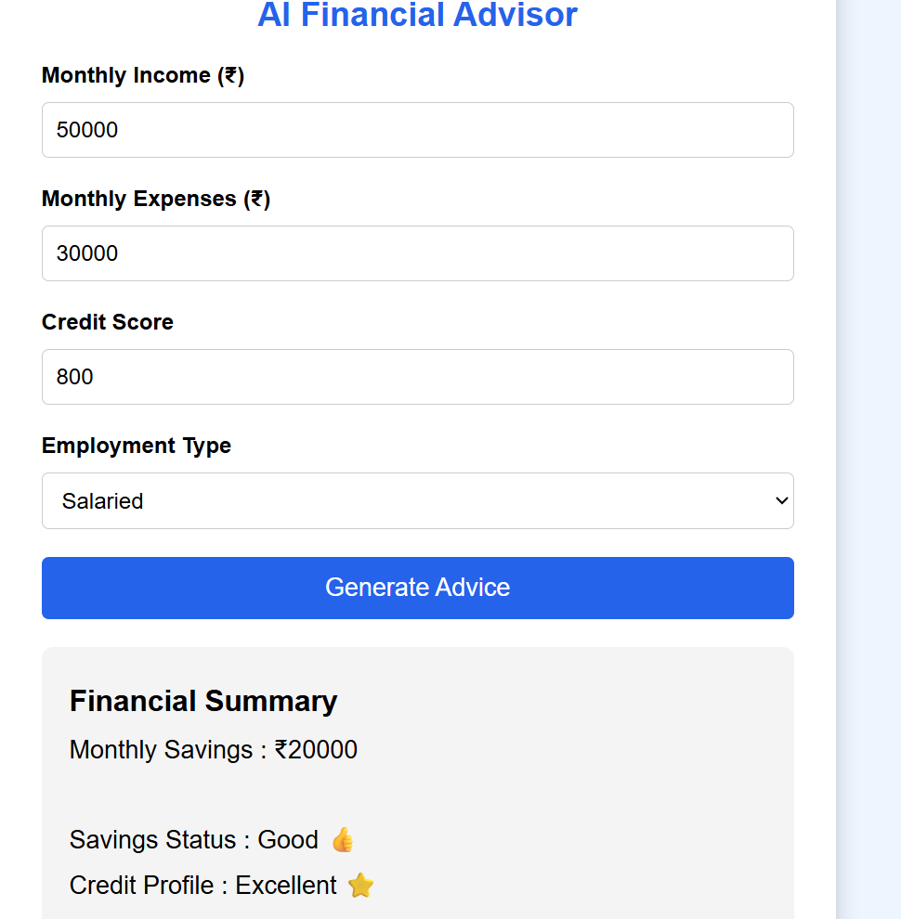
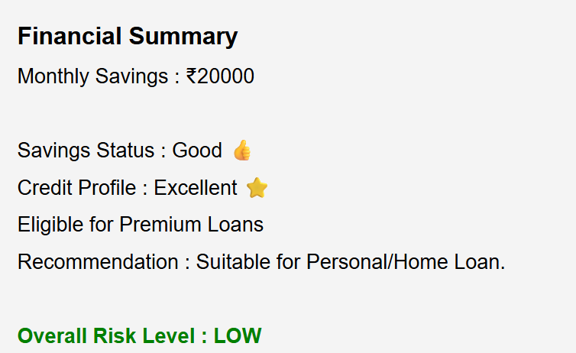
Style.css:
*{
margin:0;
padding:0;
box-sizing:border-box;
font-family:Arial,sans-serif;
}

body{
background:#f5f7fa;
color:#333;
}

header{
background:#1e3a8a;
color:white;
padding:15px;
text-align:center;
}

nav{
background:#2563eb;
padding:10px;
text-align:center;
}

nav a{
color:white;
text-decoration:none;
padding:10px 20px;
display:inline-block;
}

nav a:hover{
background:white;
color:#2563eb;
border-radius:5px;
}

.container{
width:90%;
margin:auto;
padding:20px;
}

.card{
background:white;
padding:20px;
margin:20px 0;
border-radius:10px;
box-shadow:0 0 10px gray;
}

button{
background:#2563eb;
color:white;
padding:10px 20px;
border:none;
cursor:pointer;
border-radius:5px;
}

button:hover{
background:#1e40af;
}

input,select{
width:100%;
padding:10px;
margin:10px 0;
}

footer{
background:#1e3a8a;
color:white;
text-align:center;
padding:20px;
margin-top:40px;
}
Script.js:
function showMessage(msg){
alert(msg);
}

function validateNumber(value){

if(value=="" || value<=0){

return false;

}

return true;

}

function home(){

window.location="index.html";

}

function loan(){

window.location="loan.html";

}

function credit(){

window.location="credit.html";

}

function emi(){

window.location="emi.html";

}

function advisor(){

window.location="advisor.html";

}

ADVANTAGES
- Fast loan eligibility checking.
- AI-powered financial guidance.
- Accurate EMI calculations.
- User-friendly interface.
- Secure cloud-based storage.
- Responsive design.
- Real-time results.
- Low operational cost.
- Easy deployment.
- Supports financial planning.

LIMITATIONS
- Internet connection is required.
- AI recommendations depend on user-provided data.
- Uses Google Sheets instead of an enterprise database.
- Does not integrate directly with banking systems.
- Credit score values are entered manually for demonstration.
FUTURE SCOPE
Future enhancements may include:
- Integration with bank APIs.
- Aadhaar and PAN verification.
- Multi-bank loan comparison.
- AI chatbot for financial assistance.
- Document upload and verification.
- Machine Learning-based loan prediction.
- Credit card recommendation system.
- Investment planning module.
- Android and iOS applications.
- Multi-language support.
SECURITY FEATURES
TheFinWise AI incorporates several security measures to protect user information and ensure data integrity.
- User input validation to prevent invalid data.
- Secure communication between the frontend and backend.
- Google Sheets access through authorized APIs.
- Password-protected administrative access (future enhancement).
- Data privacy maintained by storing only required information.
- Error handling to prevent application crashes.
PERFORMANCE ANALYSIS
The application was tested with different financial data and produced accurate results within a few seconds.
Performance Metrics
Parameter | Result
Response Time | Less than 2 seconds
EMI Calculation Accuracy | 100%
Loan Eligibility Accuracy | High
User Interface Performance | Excellent
Mobile Responsiveness | Supported
APPLICATIONS
The proposed system can be used in various sectors.
- Banks
- NBFCs (Non-Banking Financial Companies)
- FinTech Companies
- Educational Institutions
- Loan Consultants
- Personal Financial Planning
- Digital Banking Platforms
- Credit Analysis Services

PROJECT OUTCOMES
The project successfully achieved the following outcomes:
- Developed a responsive financial advisory website.
- Implemented an automated loan eligibility checker.
- Designed an accurate EMI calculator.
- Classified users based on their credit score.
- Generated AI-powered financial recommendations.
- Stored user information using Google Sheets.
- Improved financial awareness and decision-making.
LIMITATIONS
Although the application performs well, it has some limitations.
- Requires an internet connection.
- Uses sample financial rules.
- Does not connect directly to banking systems.
- AI recommendations depend on user-provided data.
- Google Sheets is suitable for small-scale applications only
FUTURE ENHANCEMENTS
The project can be extended with advanced features such as:
- Integration with bank APIs.
- Aadhaar and PAN verification.
- OCR for document scanning.
- Machine Learning-based loan prediction.
- Fraud detection using AI.
- Mobile application development.
- Voice-enabled AI assistant.
- Multi-language support.
- Cloud database (MySQL/Firebase).
- User login and authentication.

CONCLUSION
TheFinWise AI demonstrates how Artificial Intelligence can improve financial decision-making by automating loan eligibility assessment, credit analysis, and EMI calculations. The application combines modern web technologies with AI-generated recommendations to provide users with accurate, reliable, and personalized financial guidance.
The project successfully integrates HTML, CSS, JavaScript, Python (Flask), REST APIs, and Google Sheets into a responsive, secure, and user-friendly platform. It reduces manual effort, enhances transparency, and helps users make informed financial decisions. This project also provides valuable practical experience in full-stack web development, AI integration, cloud storage, and financial analytics.

